AuthTake FIDO2/WebAuthn User Guide

Registration Process
After the user logs into the system, user starts the token addition process using the link shown in the picture below.
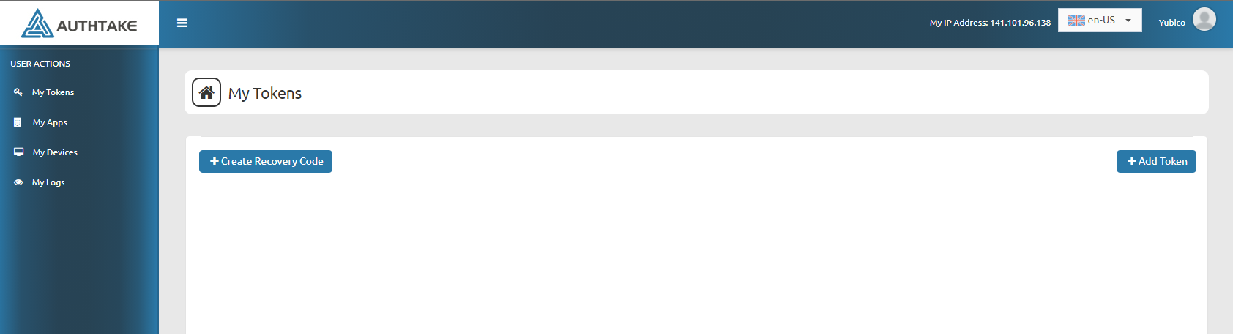
After this process, you can continue using the link shown below to add physical tokens from the screen that opens.
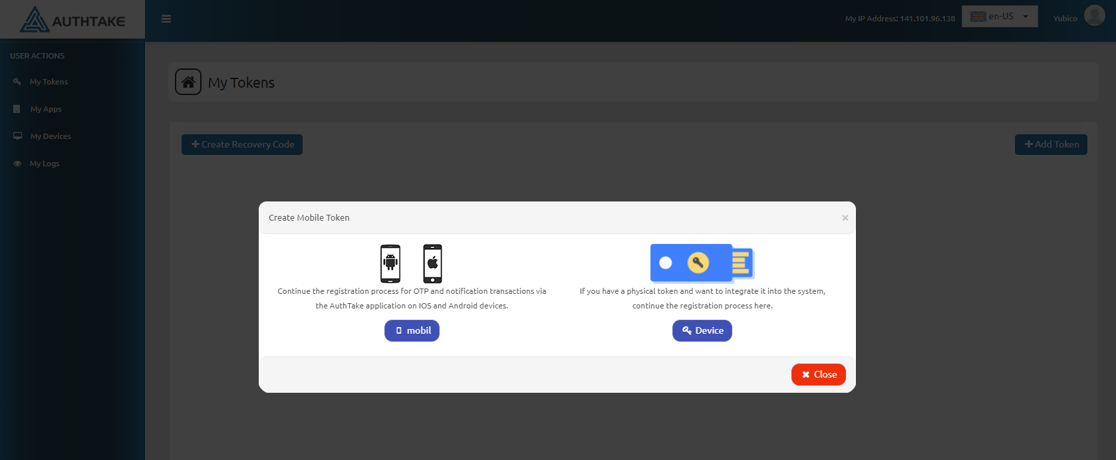
By preparing your FIDO / WebAuthn device you want to add, you can start the registration process from the link shown below. You can complete the registration process by following the instructions.
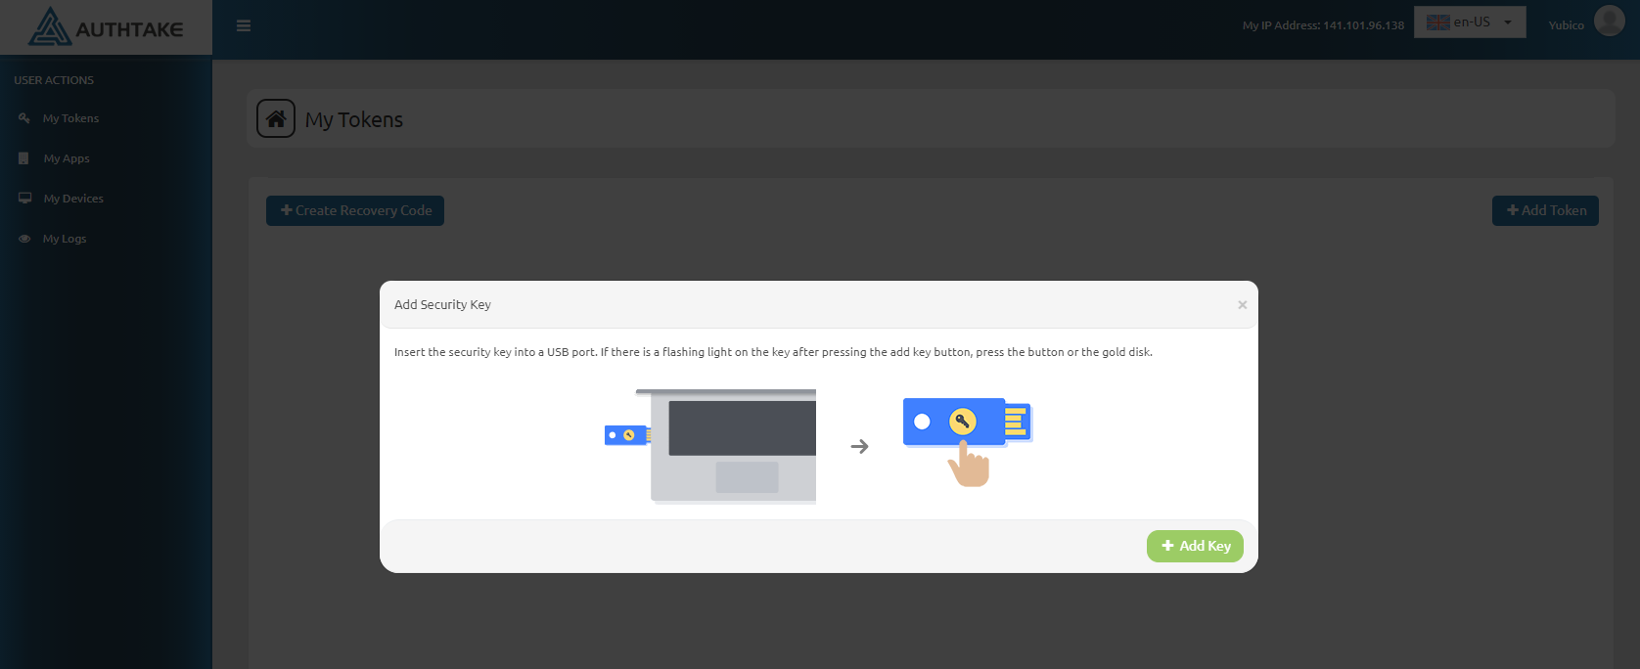

Login Process
After the registration process is completed and you logged in the system, the physical device is selected from the incoming login methods and the login process is started.
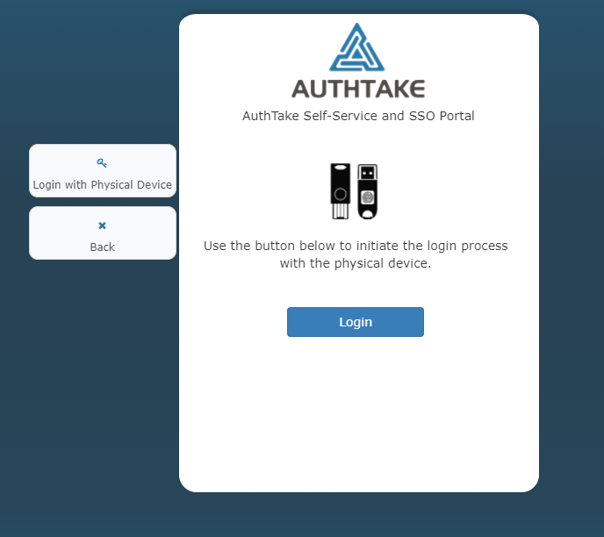
The login process is completed by following the instructions that come after the login process is started.

